Update ISO

# Overview

Update ISO fetches ISO Details saved as a configuration element and add new ISOs to it.

# Goal

It is prepared to achieve automated addition of new ISOs to the existing list which earlier was being done manually.

# Solution/Logic Design

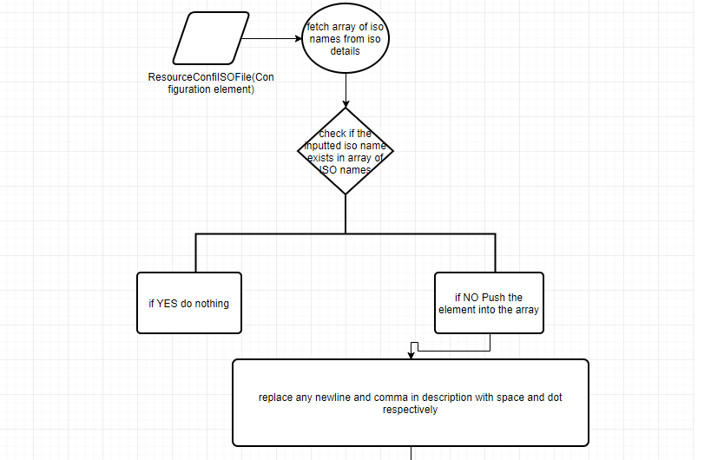

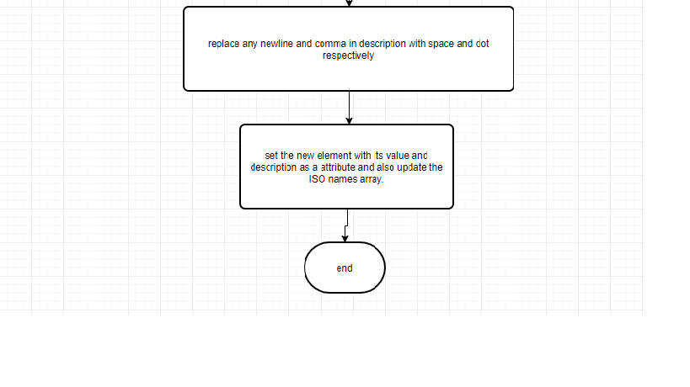

# Properties

* ISO name – Name of the ISO
* ISO Path – Path of the ISO
* ISO Description – description of the ISO

Dependencies

# Related Actions

Not Applicable

# Related Workflows

Not Applicable

# Related Configuration Elements

* ResourceConfISOFile – Configuration element which contains ISO Details from which data needs to be modified, updated or deleted.

# Attributes

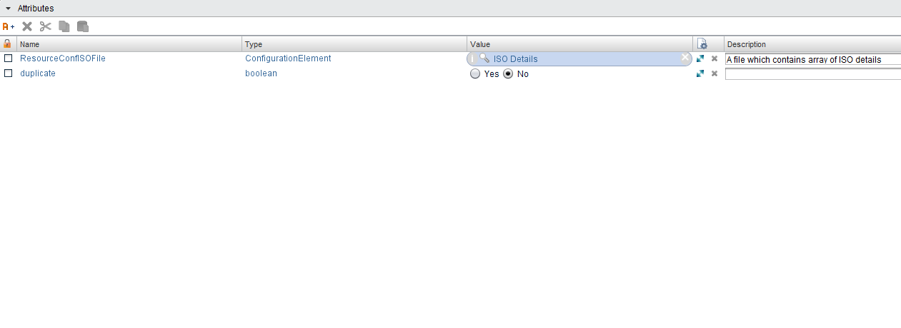

# Inputs

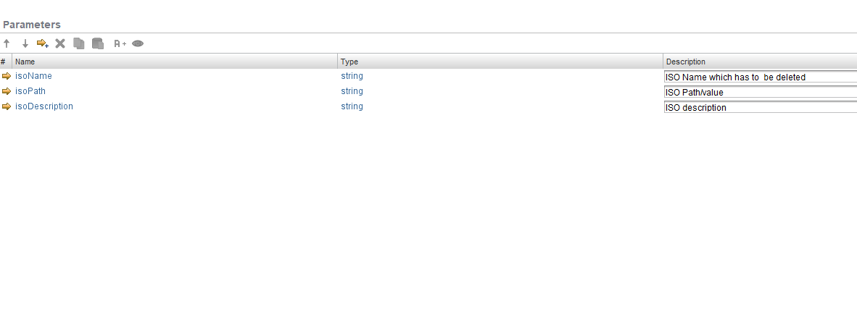

# Future Scope

It can be extended to:

* ISO details can be in different modes like a CSV file, Text file etc. .